Pharmacy Management System



Session: 2022 – 2026

**Submitted by:**

|  |  |
| --- | --- |
| Hashim Shahid | 2022-CS-821 |
| Mateen Javed | 2022-CS-832 |

**Supervised by:**

Mr. Mohsin Sheraz

Department of Computer Science

**University of Engineering and Technology, Lahore, Faisalabad Campus**

Contents

1. Introduction: 2

2. Problem Statement and Current Challenges: 2

➢ Inventory Management: 2

➢ Prescription Management: 2

➢ Customer Relationship Management: 2

➢ Compliance and Reporting: 2

3. Proposed Solution: 2

4. Solution: 2

➢ Secure Login: 2

➢ Centralized Database: 2

➢ Intuitive User Interface: 2

➢ Inventory Management: 3

➢ Prescription Management: 3

➢ Customer Relationship Management (CRM): 3

➢ Compliance and Reporting: 3

5. Scope: 3

6. Resources and Technology: 3

➢ Development Team: 3

➢ Required Resources 3

➢ Development Language: 3

➢ Database Management System: 3

7. ER Diagram: 3

8. Future Working: 4

9. Conclusion: 4

# 1. Introduction:

In today's fast-paced healthcare environment, pharmacies rely on efficient systems to manage their inventory, patient information, and prescriptions. Traditional manual methods, often involving paper records and spreadsheets, are error-prone and time-consuming. This proposal outlines a comprehensive Pharmacy Management System (PMS) to streamline pharmacy operations, enhance customer service, and ensure medication accuracy.

# 2. Problem Statement and Current Challenges:

Many pharmacies face challenges with their current systems:

* Inventory Management: Manual tracking leads to stockouts , expired medications, and difficulty maintaining optimal stock levels.
* Prescription Management: Prone to errors in data entry, potential for fraud, and challenges in tracking refills.
* Customer Relationship Management: Limited ability to track patient medication history, allergies, and preferences.
* Compliance and Reporting: Difficulty complying with regulations and generating accurate reports for insurance purposes.

# 3. Proposed Solution:

We propose the development of a Pharmacy Management System, a user-friendly software application designed to automate various pharmacy operations. This system will be built with a secure database for data storage and a user interface optimized for ease of use.

# 4. Solution:

The Pharmacy Management System will feature:

* Secure Login: Role-based access control ensures data security and privacy for staff with different user levels.
* Centralized Database: A central repository for storing medication details, patient information, prescription history, inventory levels, and financial records.
* Intuitive User Interface: User-friendly interface designed specifically for pharmacy workflows, facilitating quick access to functionalities.
* Inventory Management: Real-time tracking of medication stock levels, expiry dates, automatic reorder points, and generation of purchase orders.
* Prescription Management: Streamlined prescription processing, including electronic prescribing, drug interaction checks, refill management, and medication labeling.
* Customer Relationship Management (CRM): Comprehensive patient profiles with medication history, allergies, and personalized medicine reminders.
* Compliance and Reporting: Tools to ensure compliance with regulations, generate accurate reports for insurance claims and audits, and track key performance indicators (KPIs).

# 5. Scope:

The system can be tailored to the needs of individual pharmacies or pharmacy chains. It will accommodate a wide range of medications, including prescriptions, over-the-counter drugs, and controlled substances. Additionally, the PMS can integrate with external systems like insurance providers and medical record systems for seamless data exchange.

# 6. Resources and Technology:

* Development Team: Experienced developers specializing in database management and user interface design for healthcare applications.
* Required Resources**:** Computers for development and testing, secure database servers, and ongoing user feedback.
* Development Language: C#.
* Database Management System: My SQL.

# 7. ER Diagram:

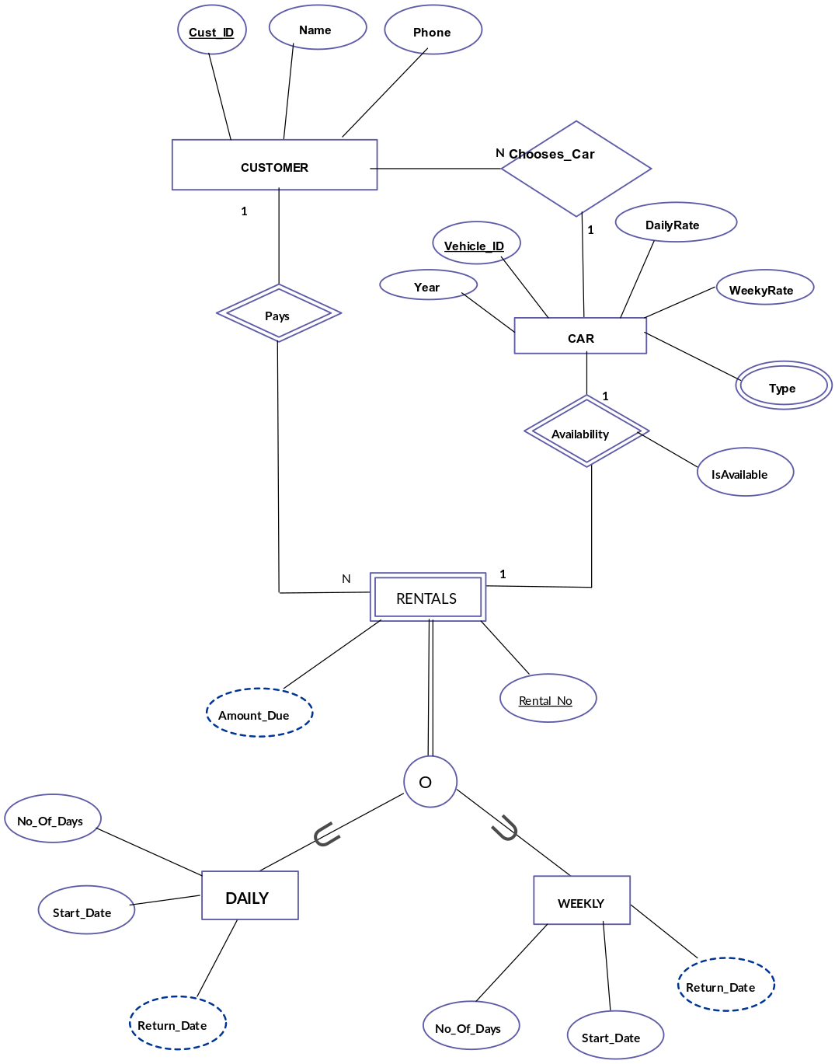

# 8. Future Working:

Following development, the system will be rigorously tested to ensure accuracy, security, and performance. Regular updates and maintenance will be provided to address emerging needs, incorporate user feedback, and maintain compatibility with evolving technologies.

# 9. Conclusion:

The Pharmacy Management System will empower pharmacies to optimize their operations, improve medication accuracy, and enhance patient care. By automating tasks, generating insightful reports, and fostering patient engagement, the PMS will ensure efficient pharmacy management in the dynamic healthcare landscape.